Exercise: Android Advanced Control
Document Number: |  | Issue Number:  Date:

TABLE OF CONTENTS
1 Exercise 1: Create a Simple Menu with Expandable Listview 2
1.1 Description 2
1.2 Create new Project. 2
1.3 Add Expandable Listview to main layout. 2
1.4 Prepare data to display. 2
1.5 Display data in Expandable Listview. 4
2 Exercise 2: Create a simple Gallery with Gridview. 4
2.1 Description. 4
2.2 Create new Project. 5
2.3 Prepare some picture with name index in Drawable. 5
2.4 Add Grivew to main layout. 5
2.5 Create a Data Adapter for loading pictures. 6
2.6 Load pictures in Gridview 6
2.7 Create Detail Activity for loading full picture. 6
2.8 Add ImageView in Detail layout. 7
2.9 Set event for Gridview to load detail Activity. 7
2.10 Load full picture in Detail Activity. 7
3 Create a simple Weather forecast use Listview. 7
3.1 Description 7
3.2 Create new Project. 8
3.3 Create a weather object. 9
3.4 Create and design a row item for Listview. 9
3.5 Add pictures and create a data file. 11
3.6 Create a Data Adapter for Listview. 12
3.7 Add Listview to main layout. 13
3.8 Create Load data method in Main Activity. 13
3.9 Load data to Listview with Paging button. 14

Exercise 1: Create a Simple Menu with Expandable Listview

Description
The purpose of this exercise is make students get familiar with Expandable Listview in Android software development. At the end of this exercise, student knows and can use Expandable Listview to build application.

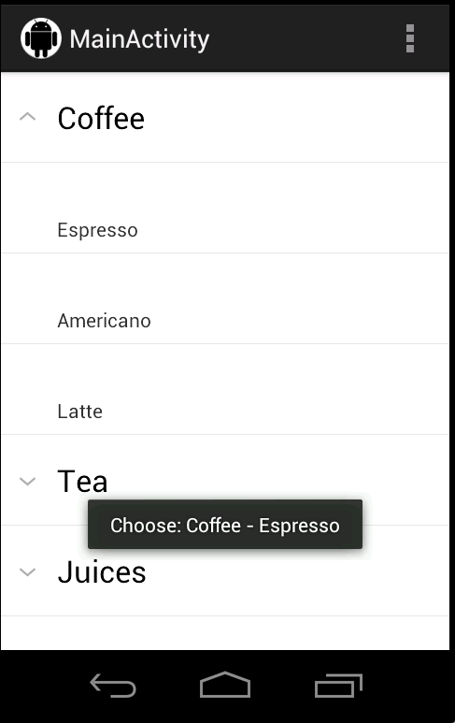

Create new Project.
In Eclipse, create new project with default activity.

Add Expandable Listview to main layout.

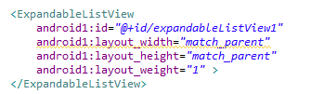

Prepare data to display.

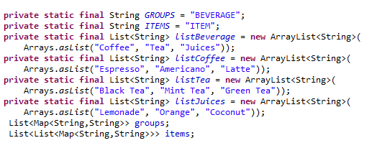

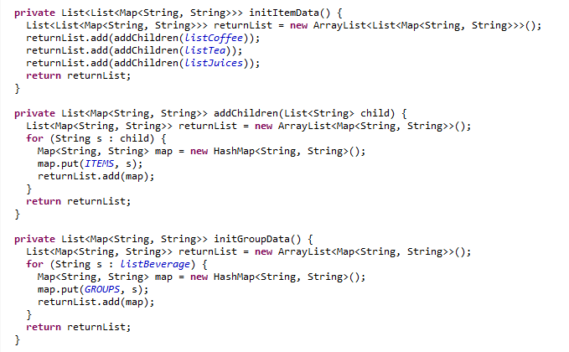

Display data in Expandable Listview.
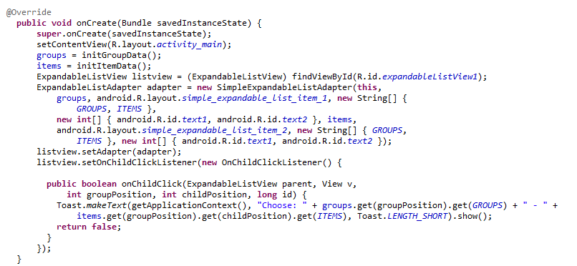

Exercise 2: Create a simple Gallery with Gridview.

Description.
The purpose of this exercise is make students get familiar with Gridview in Android software development, student also learn how to control picture size to avoid OutOfMemory error. At the end of this exercise, student knows and can use Gridview to build application.
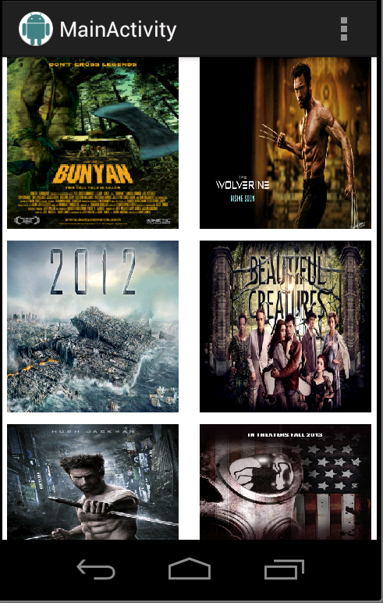

Create new Project.
In Eclipse, create new project with default activity.

Prepare some picture with name index in Drawable.
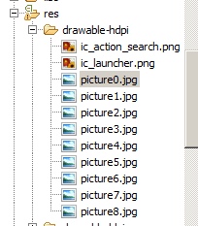

Add Grivew to main layout.
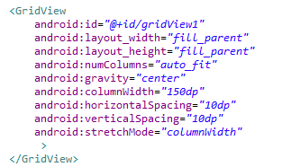

Create a Data Adapter for loading pictures.
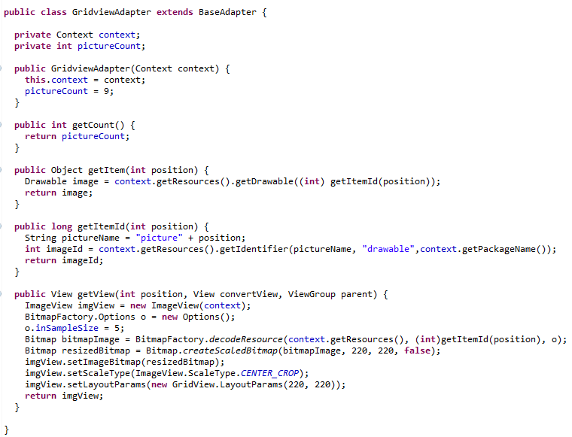

Load pictures in Gridview
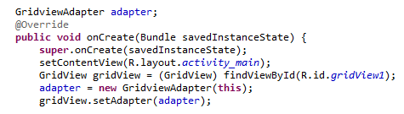

Create Detail Activity for loading full picture.
Create new Activity with layout for detail screen. This activity will load full specific picture when user choose it in Gridview.

Add ImageView in Detail layout.
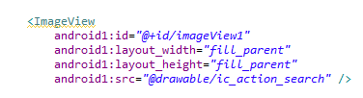

Set event for Gridview to load detail Activity.
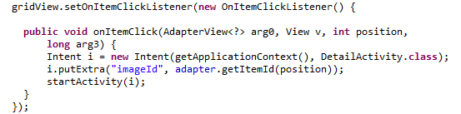

Load full picture in Detail Activity.
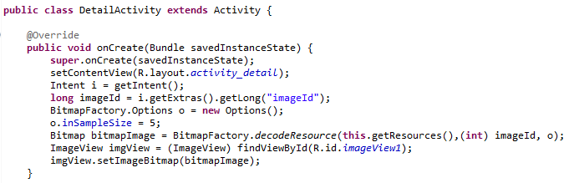

Create a simple Weather forecast use Listview.

Description
The purpose of this exercise is make students get familiar with Listview in Android software development, student also learn how to implement Paging in Listview. At the end of this exercise, student knows and can use Listview to build application.
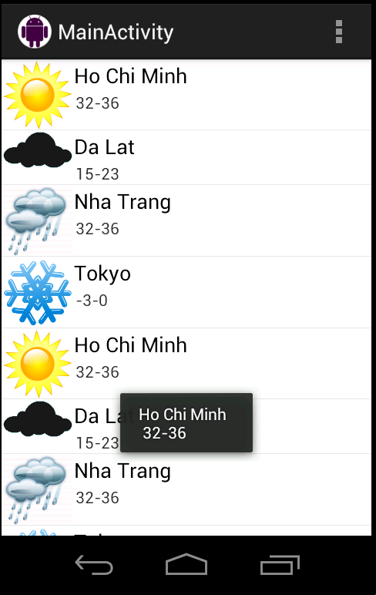

Create new Project.
In Eclipse, create new project with default activity.

Create a weather object.
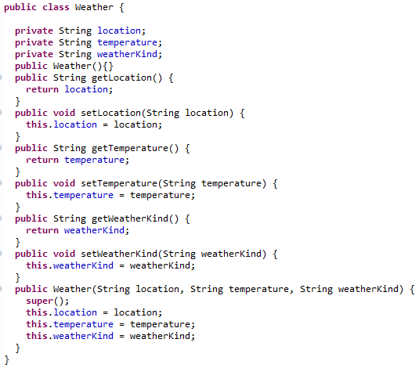

Create and design a row item for Listview.
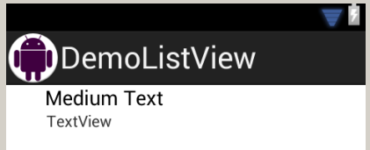

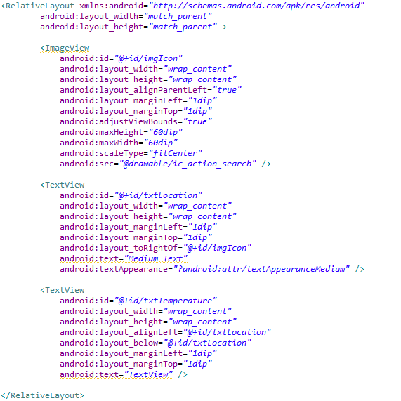

Add pictures and create a data file.
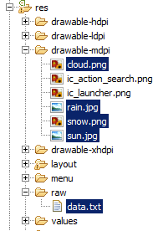

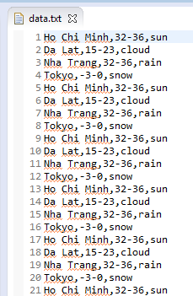

Create a Data Adapter for Listview.
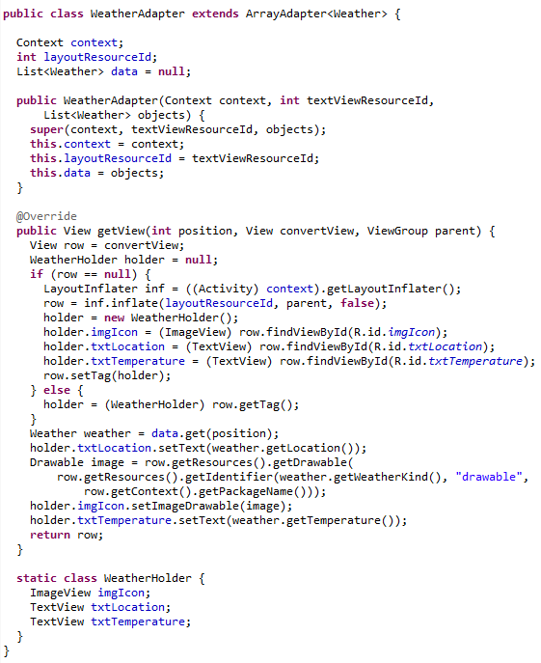

Add Listview to main layout.
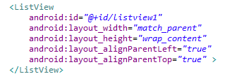

Create Load data method in Main Activity.
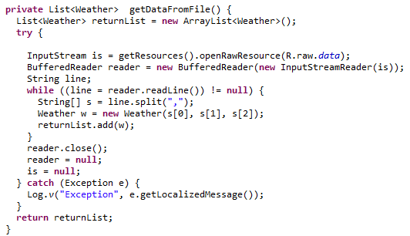

Load data to Listview with Paging button.
